**Multiplying Binary**

**This is similar to multiplying decimals using the following method;**

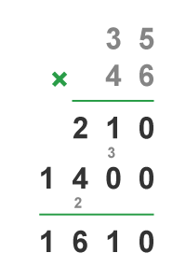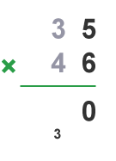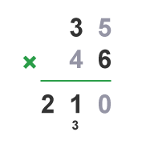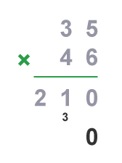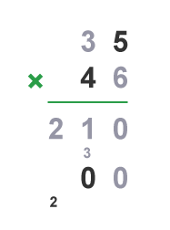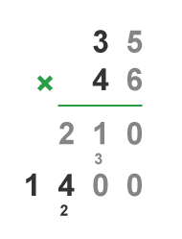

What you must remember when multiplying binary is to ignore any multiplications with the binary (0).

Example 1:)

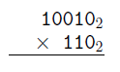

|  |  |  |  |  |  |  |  |
| --- | --- | --- | --- | --- | --- | --- | --- |
|  |  | 1 | 0 | 0 | 1 | 0 | 18 |
|  | **X** |  |  | 1 | 1 | 0 | 6 |
|  |  | 0 | 0 | 0 | 0 | 0 |  |
|  | 1 | 0 | 0 | 1 | 0 | 0 |  |
| 1 | 0 | 0 | 1 | 0 | 0 | 0 |  |
| 1 | 1 | 0 | 1 | 1 | 0 | 0 | 108 |

Exercise 1:) Exercise 2:) Exercise 3:)

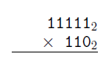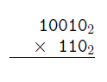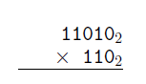

E1:)

|  |  |  |  |  |  |  |  |
| --- | --- | --- | --- | --- | --- | --- | --- |
|  |  | 1 | 1 | 0 | 1 | 0 | 26 |
|  | **X** |  |  | 1 | 1 | 0 | 6 |
|  |  | 0 | 0 | 0 | 0 | 0 |  |
|  | 1 | 1 | 0 | 1 | 0 | 0 |  |
| 1 | 1 | 0 | 1 | 0 | 0 | 0 |  |
| 10 | 0 | 1 | 1 | 1 | 0 | 0 | 156 |

E2:)

|  |  |  |  |  |  |  |  |
| --- | --- | --- | --- | --- | --- | --- | --- |
|  |  | 1 | 0 | 0 | 1 | 0 | 18 |
|  | **X** |  |  | 1 | 1 | 0 | 6 |
|  |  | 0 | 0 | 0 | 0 | 0 |  |
|  | 1 | 0 | 0 | 1 | 0 | 0 |  |
| 1 | 0 | 0 | 1 | 0 | 0 | 0 |  |
| 1 | 1 | 0 | 1 | 1 | 0 | 0 | 108 |

E3:)

|  |  |  |  |  |  |  |  |
| --- | --- | --- | --- | --- | --- | --- | --- |
|  |  | 1 | 1 | 1 | 1 | 1 | 31 |
|  | **X** |  |  | 1 | 1 | 0 | 6 |
|  |  | 0 | 0 | 0 | 0 | 0 |  |
|  | 1 | 1 | 1 | 1 | 1 | 0 |  |
| 1 | 1 | 1 | 1 | 1 | 0 | 0 |  |
| 11 | 1 | 1 | 1 | 0 | 1 | 0 | 186 |